

**Toyo Toys Documentation**

**This is to certify that**

**Mr. Shakir Ali, A Khan, Guharram Ghani , Shahnawaz Ghani**

**Has successfully Designed & Developed**

**Toyo Toys Project**

**Submitted by: Shakir Ali**

**Date of Issue: 15-dec-2018**

**ACKNOWLEDGEMENT**

I would like to acknowledge all those who have given me moral support and helped in making the project a success.

I wish to express my gratitude to eProject Team at Head Office who guided and helped me. Also, I would like to express my gratitude to all the staff members of my centre for not only providing me opportunity to work with them on this project, but also for their support and encouragement throughout the process.

I also express my sincere gratitude to eProject Team from Aptech Head Office and my project guide at the organization for his valuable guidance and support for completion of this project.

Final, I would like to offer many thanks to all my colleagues for their valuable suggestions and constructive feedback.

**TABLE OF CONTENT**

**Part 1: Project Brief .........................................................................** 1

I. PROBLEM DEFINITION ..................................................... 1

II. CUSTOMER REQUIREMENT SPECIFICATION ............. 2

IV. PROJECT PLAN ................................................................. 4

1. Details ........................................................................... 4

2. Project Initiation/Requirement Document .................... 4

3. Deliverables .................................................................. 4

4. Quality Plan .................................................................. 5

**Part 2: Project Design** ......................................................................6

II. GUI DESIGN ........................................................................ 7

**Part 3: User Guide** .......................................................................... 14

I. SYSTEM REQUIREMENT……………………...…………14

**Part4: Project Information**………………………………….…….17

TaskSheet................................................................................ 17

**PART 1: PROJECT BRIEF 1**

1. **PROBLEM DEFINITION**

TOYO Toys is selling various types of Toys. Company has a huge collection of Toys for different segments of kids. The company advertises by distributing the pamphlets, advertising on television and so on. Due to rapid development in internet field, the company decides to launch a website where people will get all the information about the various products available with them easily.

**PART 1: PROJECT BRIEF 2**

**II.** **CUSTOMER SPECIFICATION**

1. Home Page should contain logo of the site with proper sections and details of toys with suitable images.
2. The site should display a menu which will contain the options for brief introduction about the various toy products available, location of the shop and any other information if required.
3. The information should be categorized according to the brand names of the products like if a User wants to see only “MATTEL” products or any other companies products then he/she can click on a Link/button/menu etc and can see only that Brand products.
4. Another category option for Age Group of kids should be created and accordingly the toys should be listed.
5. When a user selects any particular brand, a list of products for that brand will be displayed
6. A brief summary of features of individual products should be displayed on the Web Page along with the product but detailed Features should be stored in Individual Word documents which can be downloaded or viewed by the User who wishes to see the same.
7. The user should also be able to compare the various products of different as well as similar brands.
8. There should be a “Contact Us” page which will have the Address of the Company which is as follows and the mail address which when clicked will invoke the local mail client from where they can send an email.

**PART 1: PROJECT BRIEF 4**

**IV. PROJECT PLAN**

1. Details

* + Name of the client: Toyo Toys
  + Date: 15-DEC-2018
  + Project Objectives: Create a static website where people can easily view products , their details , compare products , map should be there , easy to navigate and the site must be responding for visitors’ good experience.
  + Scope: This project covers is to manage product information only, don’t support administration of dealers, customers. Other aspects such as late fine will not be covered.
* Our understanding of client organization: Toyo toys is a company which deals in various data storage products right from cars to other toys devices. Toyo Toys products have become so popular that the demand for the products is not only coming from local market but also international market.

2. Project Initiation / Requirement Document

* The form detail about products information
* The requirement specification documents of user’s functionalities

3. Deliverable

**PART 1: PROJECT BRIEF 5**

* The documents to be handed over to the client such as CRS, Design Document, User Manual.

4. Quality Plan

* Review Activities
* Testing Activities

**V.** **SYSTEM REQUIREMENT**

1. Software requirement

* A minimum computer system that will help you access all the tools in the courses is a Pentium 166 or better
* 64 Megabytes of RAM or better
* Windows 98 or higher

2. Hardware requirement

* Notepad/HTML editor
* Dreamweaver
* IE 5.0/ Netscape 6.0

**7**

**II.** **GUI DESIGN**

**Index page:** This page serves as home page of the site where user is

Introduced to the site it also categorizes all the functions of the site.

**Product page:** Shows product types and photo categories info.

**Age:** Where people can select toys according to their children age.

**Contact page:** Contact information about Toyo Toys as address, telephone

number and mail-id

**About us page:** A brief introduction about Toyo Toys is included on the page.

**Compare:** Here visitors can find a better and suitable products according to their need by comparing products of similar and different brands.

**Part 2: Project Design 8**

**Index**

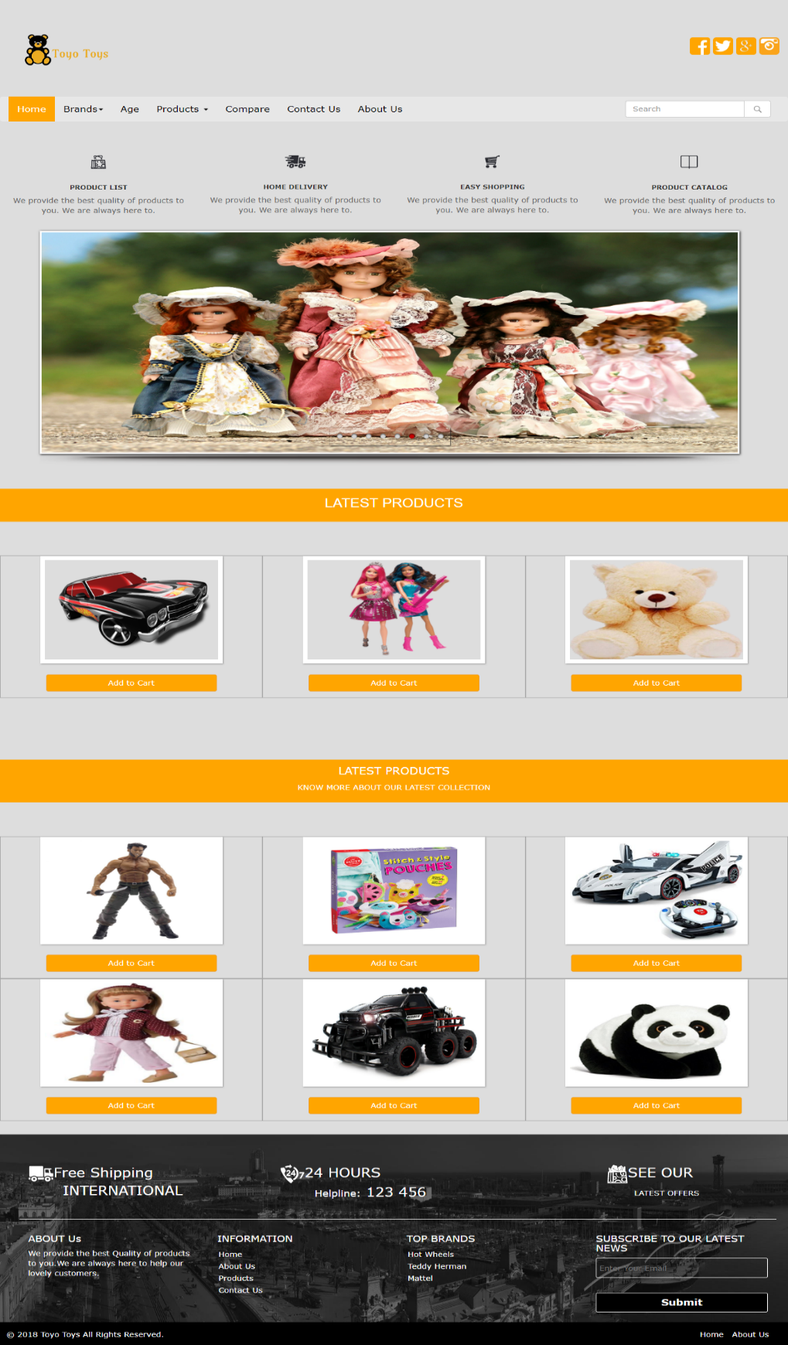

**Part 2: Project Design 10**

**Brands**

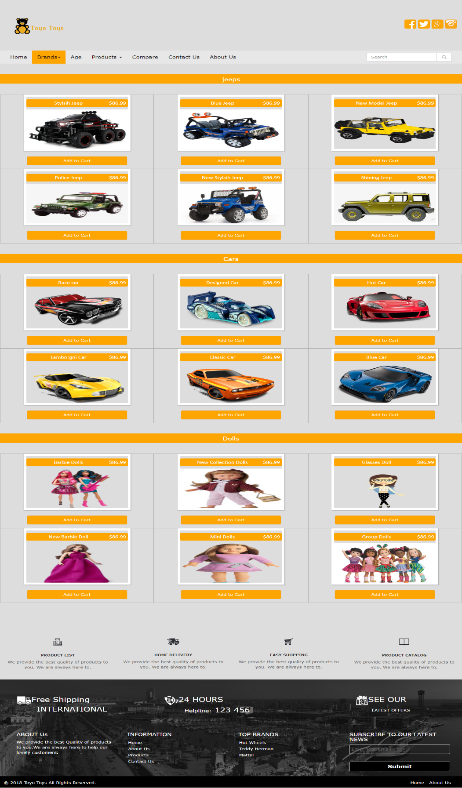

**Part 2: Project Design 11**

**Products**

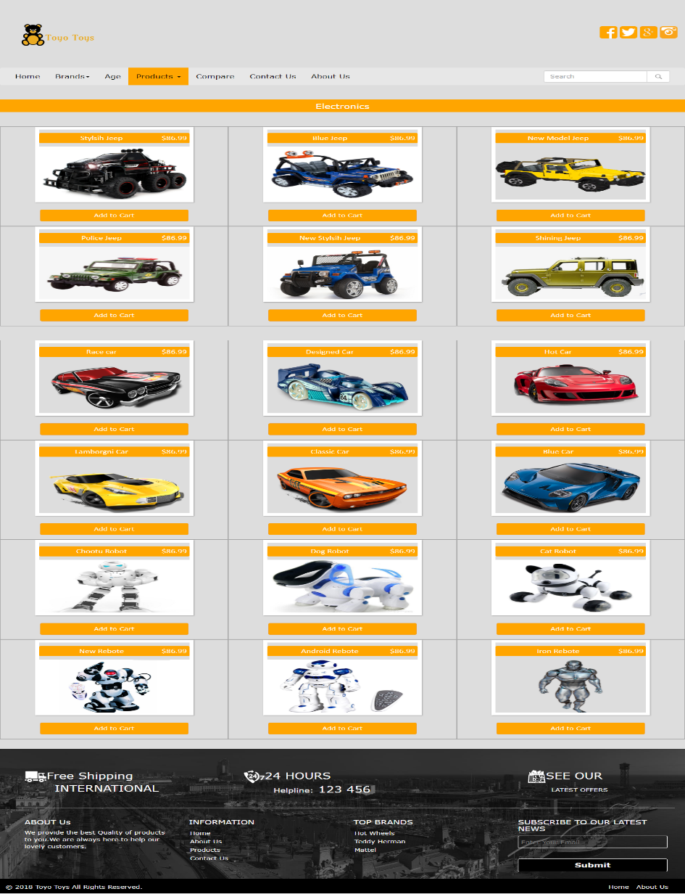

**Part 2: Project Design 12**

**Age**

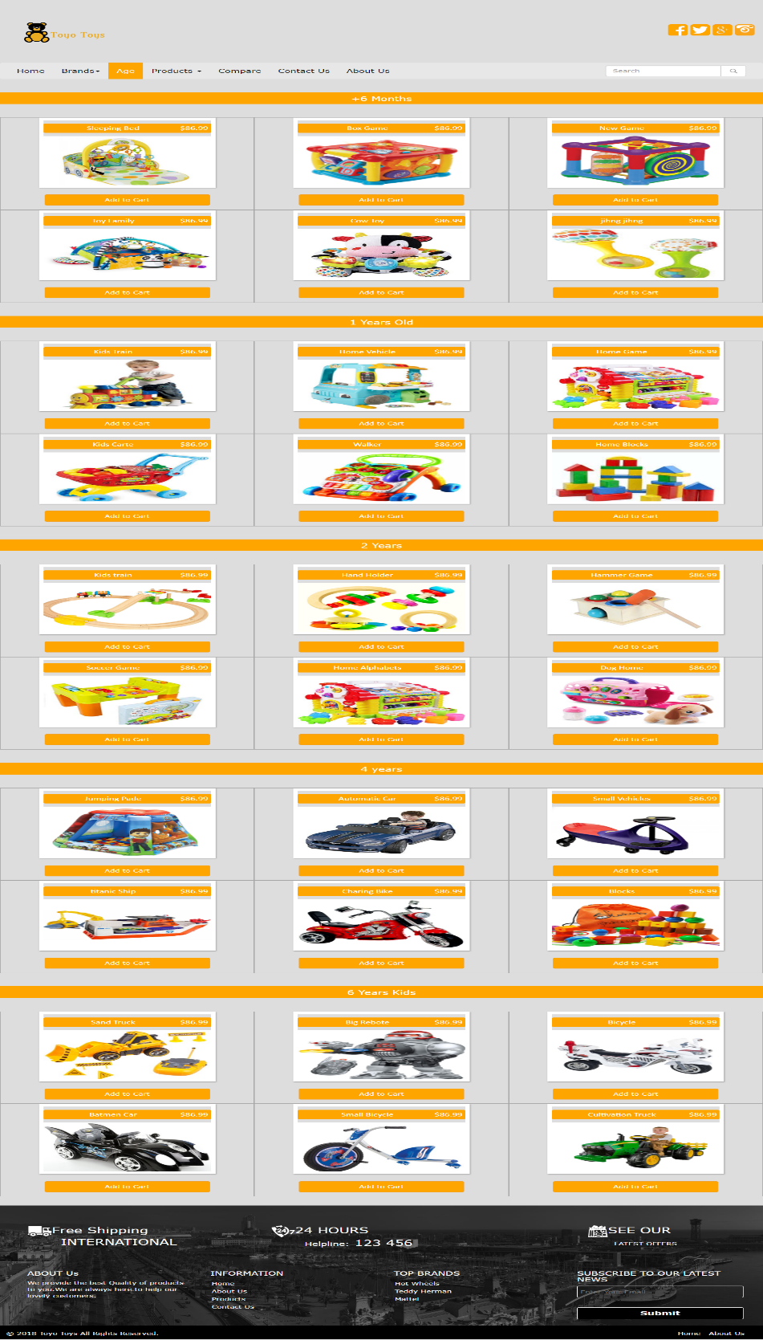

**Part 2: Project Design 12**

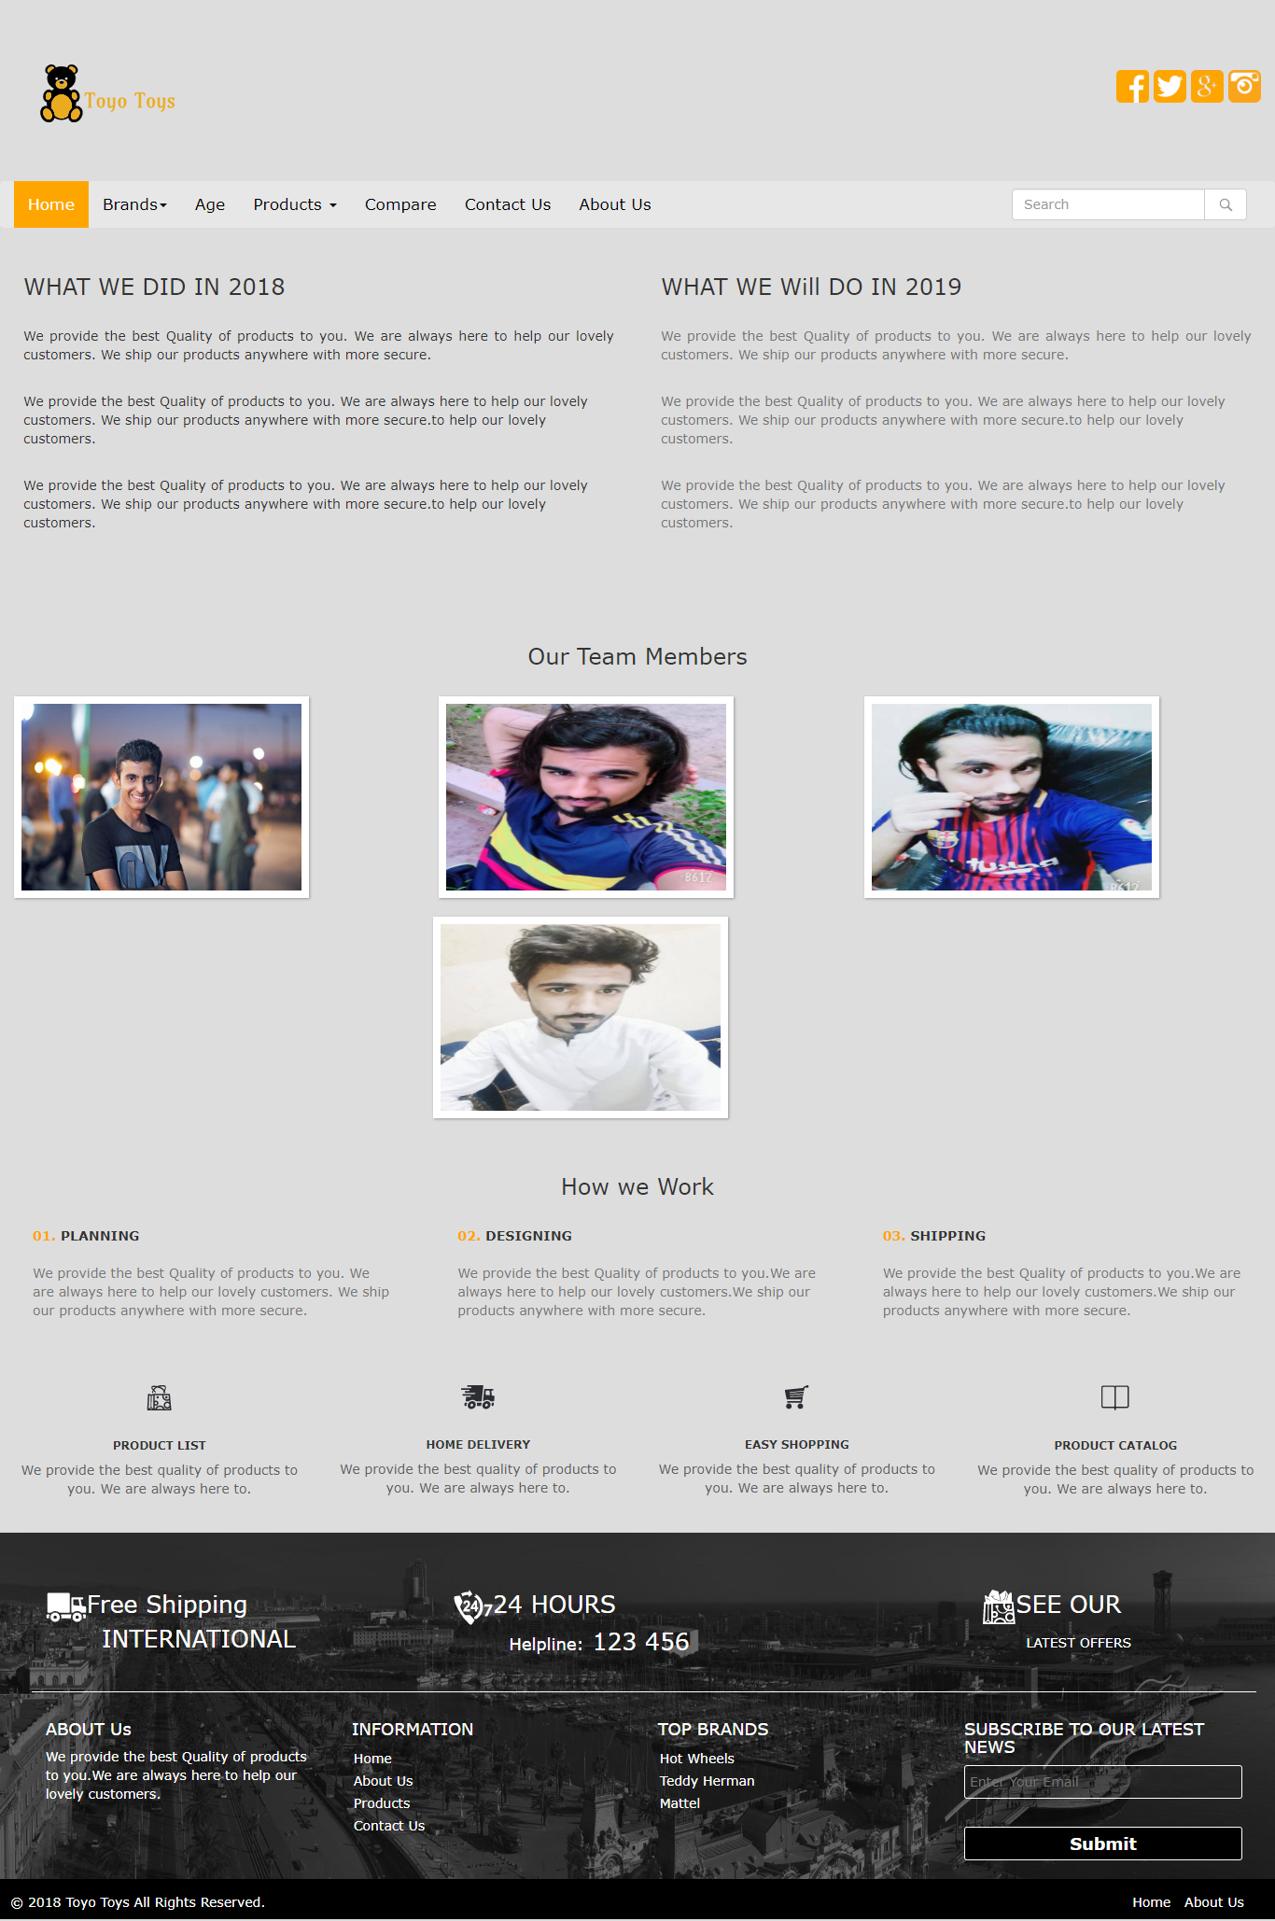 **About Us**

**Part 2: Project Design 12**

**Compare Products**

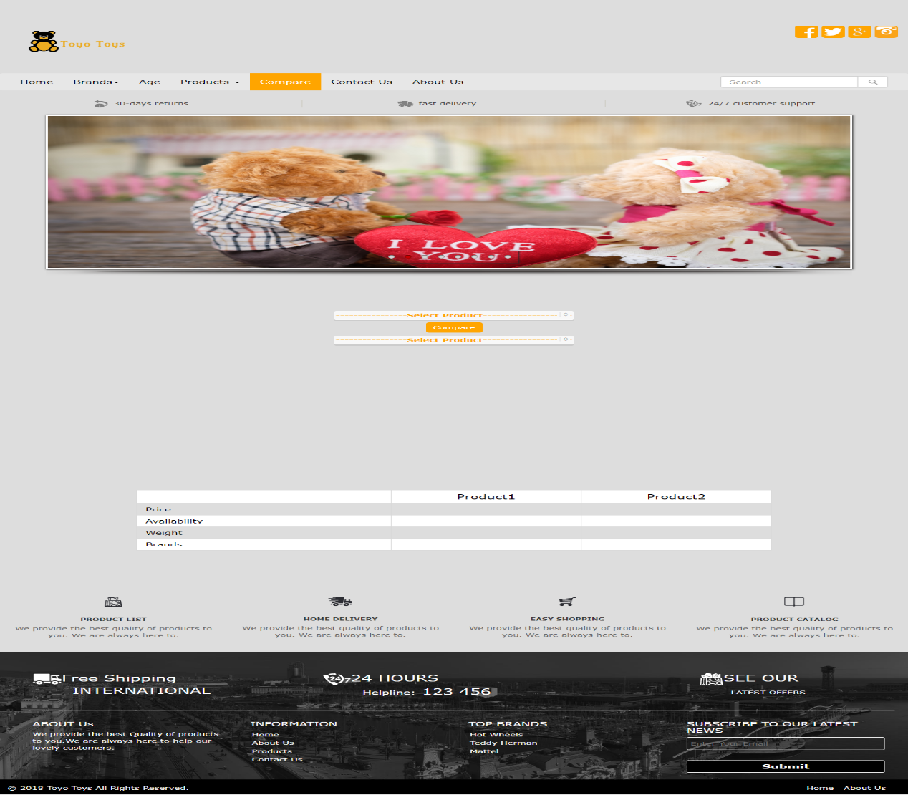

**Part 2: Project Design 12**

**Contact Us**

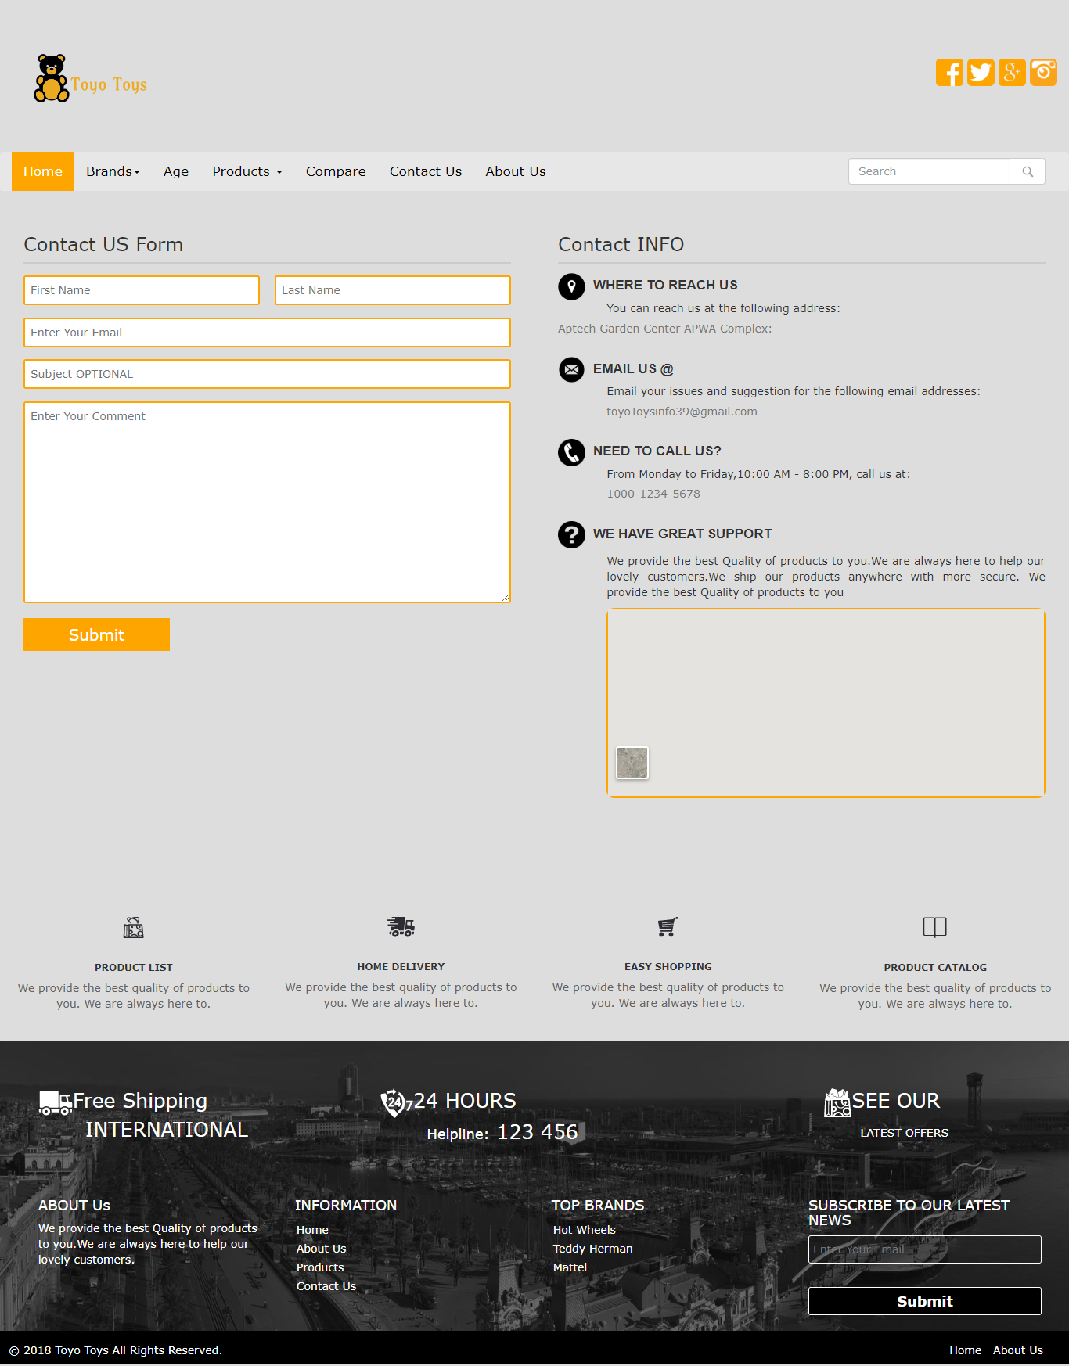

1. **System Requirement**

|  |  |  |
| --- | --- | --- |
| No | Items | Description |
| 1 | Operating System | Windows 98, 2000, XP, or higher |
| 2 | Web Browser | Modern Browser i.e Chrome , Mozilla ,Opera , Safari |
| 3 | Software | Dreamweaver / FrontPage /Notepad++ |
| 4 | Zoom out capability | As Possible |
| 5 | Screen resolution  (best view) | 1136 x 640 or more |
| 6 | Responsive | yes |

**Index page Coding**

**<!DOCTYPE >**

**<html>**

**<head>**

**<title>Toyo toys</title>**

**<link rel="icon" href="favicon.ico" type="icon">**

**<link rel="stylesheet" href="css/styles.css">**

**<script src="Js/jquery.min.js"></script>**

**<script src="Js/bootstrap.min.js"></script>**

**<link href="css/style.css" type="text/css" rel="stylesheet">**

**<script src="Js/script.js"></script>**

**<link href="css/hover.css" rel="stylesheet">**

**<link href="css/slider.css" type="text/css" rel="stylesheet">**

**<link rel="stylesheet" type="text/css" href="engine1/style.css" />**

**<script type="text/javascript" src="engine1/jquery.js"></script>**

**<script type="text/javascript" src="sliderengine/jquery.js"></script>**

**<script type="text/javascript" src="sliderengine/jquery.hislider.js"></script>**

**</head>**

**<body style="background-color:#dddddd;">**

**<!-- header start -->**

**<div id="header">**

**<div class="row">**

**<div class="col-sm-6">**

**<br>**

**<a href="index.html"><img src="2ndlogo.jpg" class="logo" style="margin-top:0%;"></a>**

**</div>**

**<div class="col-sm-6">**

**<br><br><br>**

**<div class="social--icons" style="float:right;" align="right" >**

**<a href="https://www.facebook.com/profile.php?id=100004946942170"><img src="icons/sg1.png" style="margin-top:10%" onmouseover="this.src='icons/s1.png'" onmouseout="this.src='icons/sg1.png'" class="s1"/></a>**

**<a href="https://twitter.com/shakirali00715"><img src="icons/sg2.png" style="margin-top:10%" onmouseover="this.src='icons/s2.png'" onmouseout="this.src='icons/sg2.png'" class="s2"/></a>**

**<a href="https://gmail.com"><img src="icons/sg3.png" style="margin-top:10%" onmouseover="this.src='icons/s3.png'" onmouseout="this.src='icons/sg3.png'" class="s3"/></a>**

**<a href="https://www.instagram.com/shakir_ali00/"><img src="icons/sg4.png" style="margin-top:10%" onmouseover="this.src='icons/s4.png'" onmouseout="this.src='icons/sg4.png'" class="s4"/></a>**

**</div>**

**</div>**

**</div>**

**</div>**

**<!-- headr end -->**

**<!-- navbar start -->**

**<nav class="navbar navbar-inverse" style="margin-top:1%;background-color:#e7e7e7;border:0;">**

**<div class="container-fluid">**

**<ul class="nav navbar-nav">**

**<li class="active"><a href="index.html">Home</a></li>**

**<li class="dropdown"> <a class="dropdown-toggle" data-toggle="dropdown" href="#">Brands<span class="caret"></span></a>**

**<ul class="dropdown-menu">**

**<li><a href="hotwheels.html">Hot Wheels</a>**

**</li>**

**<li><a href="teddyherman.html">Teddy Herman</a>**

**<li><a href="mattel.html">Mattel</a>**

**</ul>**

**</li>**

**<li><a href="age.html">Age</a></li>**

**<li class="dropdown"> <a class="dropdown-toggle" data-toggle="dropdown" href="#">Products <span class="caret"></span></a>**

**<ul class="dropdown-menu">**

**<li><a href="electronics.html">Electronics</a></li>**

**<li><a href="dolls.html">Dolls</a></li>**

**<li><a href="softtoys.html">Soft Toys</a></li>**

**<li><a href="action.html">Action Figures</a></li>**

**<li><a href="product.html">All Products</a></li>**

**</ul>**

**</li>**

**<li><a href="compare.html">Compare</a></li>**

**<li><a href="contactus.html">Contact Us</a></li>**

**<li><a href="about.html">About Us</a></li>**

**</ul>**

**<div class="searchbar" style="float:right">**

**<form class="navbar-form navbar-left">**

**<div class="input-group">**

**<input type="text" class="form-control" placeholder="Search">**

**<div class="input-group-btn">**

**<button class="btn btn-default" type="submit">**

**<img src="icons/11.png" width="20px" height="20px">**

**</button>**

**</div>**

**</div>**

**</form>**

**</div>**

**</div>**

**</nav>**

**<!-- navbar end -->**

**<div class="row" style="margin-top:5%;">**

**<div class="col-sm-3"><center><img src="icons/7.png">**

**<h6 style="margin-top:10%;"><strong>PRODUCT LIST</strong></h6>**

**<p style="color:#626262;">We provide the best quality of products to you. We are always here to.</p>**

**</center>**

**</div>**

**<div class="col-sm-3"><center><img src="icons/8.png">**

**<h6 style="margin-top:10%;"><strong>HOME DELIVERY</strong></h6>**

**<p style="color:#626262;">We provide the best quality of products to you. We are always here to.</p>**

**</center>**

**</div>**

**<div class="col-sm-3"><center><img src="icons/9.png">**

**<h6 style="margin-top:10%;"><strong>EASY SHOPPING</strong></h6>**

**<p style="color:#626262;">We provide the best quality of products to you. We are always here to.</p>**

**</center>**

**</div>**

**<div class="col-sm-3"><center><img src="icons/10.png">**

**<h6 style="margin-top:10%;"><strong>PRODUCT CATALOG</strong></h6>**

**<p style="color:#626262;">We provide the best quality of products to you. We are always here to.</p>**

**</center>**

**</div>**

**</div>**

**<div style="clear:both;height:20px;width:100%"></div>**

**<div id='hislider1' style=" max-width:90%; max-height:450px;height:100%; margin: 0 auto;">**

**</div>**

**<div id="section">**

**<div class="bg" style="background-color:orange; height:10%; margin-top:5%;">**

**<p align="center" style="font-size:25px; color:white; font-family:arial; padding:11px;">LATEST PRODUCTS</p>**

**</div>**

**<div id="latestposts" style="margin-top:5%;">**

**<div class="col-sm-4" style="border:1px solid #a6a6a6;" align="center">**

**<div class="ih-item square colored effect3 bottom_to_top"><a href="car1.html">**

**<div class="img"><img src="image/Car/car1.png" alt="Race car"></div>**

**<div class="info">**

**<h3>Race Car</h3>**

**<p>$86.99</p>**

**</div></a></div>**

**<center>**

**<a href="car1.html" style="color:white; font-weight:bold;"><button type="button" class="btn btn-warning" style="margin-top:5%; margin-bottom:3%; width:70%;"> Add to Cart</button></a>**

**</center>**

**</div>**

**<div class="col-sm-4" style="border:1px solid #a6a6a6;" align="center">**

**<div class="ih-item square colored effect3 bottom_to_top"><a href="doll1.html">**

**<div class="img"><img src="image/dolls/doll1.png" alt="Cruz Mid-Back Chair"></div>**

**<div class="info">**

**<h3>Barbie Dolls</h3>**

**<p>$59.99</p>**

**</div></a></div>**

**<center>**

**<a href="doll1.html" style="color:white; font-weight:bold;"><button type="button" class="btn btn-warning" style="margin-top:5%; margin-bottom:3%; width:70%;"> Add to Cart</button></a>**

**</center>**

**</div>**

**<div class="col-sm-4" style="border:1px solid #a6a6a6;" align="center">**

**<div class="ih-item square colored effect3 bottom_to_top"><a href="softtoy1.html">**

**<div class="img"><img src="image/soft toys/softtoy1.png" alt="Upholstered Platform Bed"></div>**

**<div class="info">**

**<h3>Cute Bear</h3>**

**<p>$53.99</p>**

**</div></a></div>**

**<center>**

**<a href="softtoy1.html" style="color:white; font-weight:bold;"><button type="button" class="btn btn-warning" style="margin-top:5%; margin-bottom:3%; width:70%;"> Add to Cart</button></a>**

**</center>**

**</div>**

**</div>**

**</div>**

**<div id="section2" style="margin-top:35%; background-color:#dddddd;" >**

**<div class="bg" style="background-color:orange;; height:13%; margin-top:5%; color:white; padding:8px;">**

**<p align="center" style="font-size:20px;">LATEST PRODUCTS</p>**

**<p align="center">KNOW MORE ABOUT OUR LATEST COLLECTION</p>**

**</div>**

**<div id="hposts" style="margin-top:5%;">**

**<div class="row" align="center">**

**<div class="col-sm-4" style="border:1px solid #a6a6a6;">**

**<div class="ih-item square effect6 top_to_bottom"><a href="action1.html">**

**<div class="img"><img src="image/action/action1.jpg" alt="Action1"></div>**

**<div class="info">**

**<h3>Super Heroes Toys</h3>**

**<p> this toy is designed for the kids who are super fan of super heroes who have saved our world several times these types of toys are loved by childrn.**

**</p>**

**</div></a></div>**

**<center>**

**<a href="action1.html" style="color:white; font-weight:bold;"><button type="button" class="btn btn-warning" style="margin-top:5%; margin-bottom:3%; width:70%;"> Add to Cart</button></a>**

**</center>**

**</div>**

**<div class="col-sm-4" style="border:1px solid #a6a6a6;" align="center">**

**<div class="ih-item square effect6 top_to_bottom"><a href="art1.html">**

**<div class="img"><img src="image/art/art1.jpg" alt="Art"></div>**

**<div class="info">**

**<h3>Artist Color Box**

**</h3>**

**<p>Children are always creative and artist from start and have very good skills in their childhood if your child is one of them so this paint box is specially for your child.</p>**

**</div></a></div>**

**<center>**

**<a href="art1.html" style="color:white; font-weight:bold;"><button type="button" class="btn btn-warning" style="margin-top:5%; margin-bottom:3%; width:70%;"> Add to Cart</button></a>**

**</center>**

**</div>**

**<div class="col-sm-4" style="border:1px solid #a6a6a6;" align="center">**

**<div class="ih-item square effect6 top_to_bottom"><a href="remotecar1.html">**

**<div class="img"><img src="image/Remoto/romote1.jpg" alt="Remote control carf"></div>**

**<div class="info">**

**<h3>Remote Control Car White</h3>**

**<p>The perfect Car for your child to play with its an updated version car with the remote control and very famous among the children now are days it has very easy control for kids.</p>**

**</div></a></div>**

**<center>**

**<a href="remotecar1.html" style="color:white; font-weight:bold;"><button type="button" class="btn btn-warning" style="margin-top:5%; margin-bottom:3%; width:70%;"> Add to Cart</button></a>**

**</center>**

**</div>**

**<div class="col-sm-4" style="border:1px solid #a6a6a6;" align="center">**

**<div class="ih-item square effect6 top_to_bottom"><a href="cpost.html">**

**<div class="img"><img src="image/dolls/doll2.jpg" alt="Doll2"></div>**

**<div class="info">**

**<h3>Doll For Princess</h3>**

**<p>This is doll is specially designed for your princess perfect for her birthday.</p>**

**</div></a></div>**

**<center>**

**<a href="doll2.html" style="color:white; font-weight:bold;"><button type="button" class="btn btn-warning" style="margin-top:5%; margin-bottom:3%; width:70%;"> Add to Cart</button></a>**

**</center>**

**</div>**

**<div class="col-sm-4" style="border:1px solid #a6a6a6;" align="center">**

**<div class="ih-item square effect6 top_to_bottom"><a href="jeep.html">**

**<div class="img"><img src="image/Car/jeep.jpeg" alt=" jeep"></div>**

**<div class="info">**

**<h3>Monster Jeep</h3>**

**<p>**

**Monster jeep is the new car from hot wheels company and it's very good for your child.</p>**

**</div></a></div>**

**<center>**

**<a href="panda.html" style="color:white; font-weight:bold;"><button type="button" class="btn btn-warning" style="margin-top:5%; margin-bottom:3%; width:70%;"> Add to Cart</button></a>**

**</center>**

**</div>**

**<div class="col-sm-4" style="border:1px solid #a6a6a6;" align="center">**

**<div class="ih-item square effect6 top_to_bottom"><a href="softtoys2.html">**

**<div class="img"><img src="image/soft toys/panda.jpg" alt="panda"></div>**

**<div class="info">**

**<h3>Panda </h3>**

**<p>Panda are the cutest animal in our world and these soft toys are suitable for your daughter and to be her friend,</p>**

**</div>**

**</a></div>**

**<center>**

**<a href="panda.html" style="color:white; font-weight:bold;"><button type="button" class="btn btn-warning" style="margin-top:5%; margin-bottom:3%; width:70%;"> Add to Cart</button></a>**

**</center>**

**</div>**

**</div>**

**</div>**

**</div>**

**<div id="section3">**

**<div class="fttxt">**

**<div class="row" style="margin-top:3%">**

**<div class="col-sm-4">**

**<p class="shipping" align="left"><img src="icons/4.png">Free Shipping<br>**

**<span style="color:white; margin-left:14.8%;">INTERNATIONAL</span> </p>**

**</div>**

**<div class="col-sm-4">**

**<p class="shipping"><img src="icons/6.png">24 HOURS<br>**

**<span style="color:white; font-size:18px; margin-left:14.5%;">Helpline:</span> <span style="color:white">123 456</span> </p>**

**</div>**

**<div class="col-sm-4">**

**<p class="shipping" align="center"><img src="icons/5.png">SEE OUR<br>**

**</p>**

**<p align="center" style="color:white; margin-left:14%;">LATEST OFFERS<br>**

**</p>**

**</div>**

**</div>**

**<div class="line"></div>**

**<div class="row" style="margin-top:1.5%">**

**<div class="col-sm-3">**

**<h4 style="color:white;">ABOUT Us</h4>**

**<p style="color:white;"> We provide the best Quality of products to you.We are always here to help our lovely customers. </p>**

**</div>**

**<div class="col-sm-3">**

**<h4 style="color:white;">INFORMATION</h4>**

**<ul class="inform">**

**<li><a href="index.html">Home</a></li>**

**<li><a href="about.html">About Us</a></li>**

**<li><a href="allproducts.html">Products</a></li>**

**<li><a href="contactus.html">Contact Us</a></li>**

**</ul>**

**</div>**

**<div class="col-sm-3">**

**<h4 style="color:white;">TOP BRANDS</h4>**

**<ul class="inform">**

**<li><a href="hotwheels.html">Hot Wheels</a></li>**

**<li><a href="teddyherman.html">Teddy Herman</a></li>**

**<li><a href="mattel.html">Mattel</a></li>**

**</ul>**

**</div>**

**<div class="col-sm-3">**

**<h4 style="color:white;">SUBSCRIBE TO OUR LATEST NEWS</h4>**

**<input type="email" placeholder="Enter Your Email" class="subscribe">**

**<input type="submit" placeholder="Enter Your Email" class="subsbtn">**

**</div>**

**</div>**

**</div>**

**</div>**

**<div id="footer">**

**<div id="footer2">**

**<span style="color:white;padding:10px;">&copy 2018 Toyo Toys All Rights Reserved.</span>**

**<div class="ftnav">**

**<ul>**

**<li><a href="index.html">Home</a></li>**

**<li><a href="about.html">About Us</a></li>**

**</ul>**

**</div>**

**</div>**

**</div>**

**</body>**

**</html>**

**Task Sheet**

|  |  |  |
| --- | --- | --- |
| Student ID | Name | Task |
| 1125063 | Shakir Ali | Home page, Compare Page |
| 1135898 | Guharram Ghani | About us Page Contact us page |
| 1132095 | Shahnawaz Ghani | Brands Page, Product page |
| 1135901 | Ali khan | Age page, Documentation and testing |